Libspace backend system
Ideation Phase
Define the Problem Statements

Date | 05-03-2026
Team ID | NM2025TMID39963
Project Name | Libspace
Maximum Marks | 2 Marks

Customer Problem Statement – Libspace Backend System
The Customer Problem Statement helps identify the challenges faced by users while managing books in a digital system. Understanding the user's perspective allows the team to design a backend application that is secure, structured, and efficient.
Many small libraries, students, and individual users struggle to manage book records manually or through unorganized digital methods. Existing systems are often:
- Overly complex
- Paid or subscription-based
- Not secure
- Lacking proper user-specific data access
- Difficult to maintain
There is a need for a simple and secure backend system that allows users to manage books efficiently while ensuring data privacy and authentication control.

Identified User Challenges
- Lack of secure authentication mechanisms
- No centralized system to store and manage books
- Inability to restrict access to user-specific data
- Difficulty in updating and deleting records
- Risk of data inconsistency or duplication

Customer Needs
Users require a system that:
- Allows secure user registration and login
- Ensures passwords are encrypted and protected
- Restricts access to authorized users only
- Provides full CRUD operations for books
- Maintains proper database structure
- Ensures reliable error handling

Project Focus Based on Customer Needs
To address these challenges, the team decided to build Libspace – Backend Book Management System, which:
- Implements JWT-based authentication
- Provides secure login and logout functionality
- Enables users to perform CRUD operations on books
- Ensures user-specific data isolation
- Follows RESTful API standards
- Implements middleware for route protection

Outcome of the Customer Problem Analysis
By analyzing customer pain points, the project focuses on delivering:
- Secure backend architecture
- Structured database management
- Clean API design
- Scalable system foundation
- Real-world backend implementation practices
The ideation phase ensured that the system is not just technically functional but also aligned with real user problems and practical backend development goals.

Reference: https://miro.com/templates/customer-problem-statement/

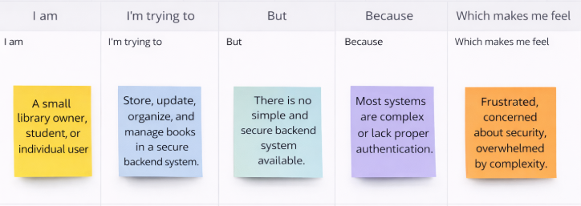

Problem Statement | I am (Customer) | I’m trying to | But | Because | Which makes me feel
PS-1 | A small library owner | Manage and organize book records digitally | Existing tools are complex or require paid subscriptions | I need a simple backend system to securely add, update, and delete books | Frustrated managing records manually
PS-2 | A student managing personal books | Keep track of books in one centralized system | There is no secure system that restricts access to my data | I want a login-based system where only I can manage my books | Concerned about data privacy
PS-3 | A individual user | Update and delete book information easily | Many systems do not provide proper authentication or data isolation | I need a secure backend with JWT authentication and protected routes | Anxious about unauthorized access
PS-4 | A beginner user with limited technical knowledge | Use a simple system to manage books without complexity | Most available platforms focus more on UI and less on backend security | I want a lightweight and secure system that is easy to use | Overwhelmed by complicated software

